**Experiment No. 8**

**Aim:** Use simple and advanced filters: **pr, head, tail, cut, paste, sort, uniq, te, grep, sed, awk.**

1. **pr command:**

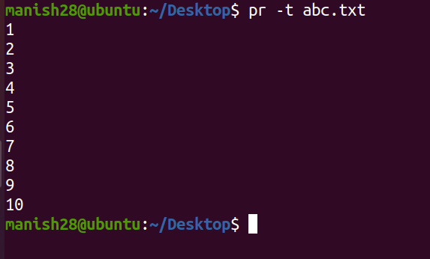

1. **head command:**

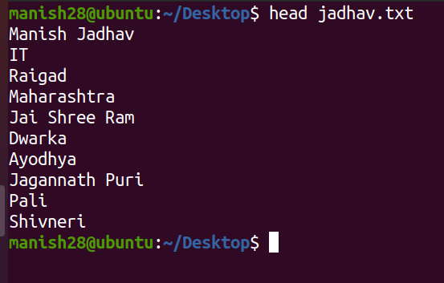

* **head -n (display n lines):**

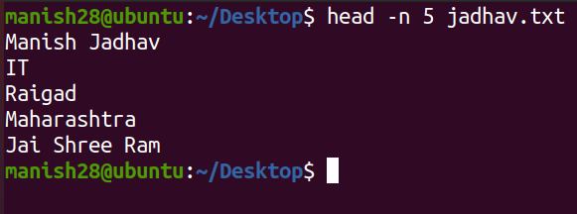

1. **tail command:**

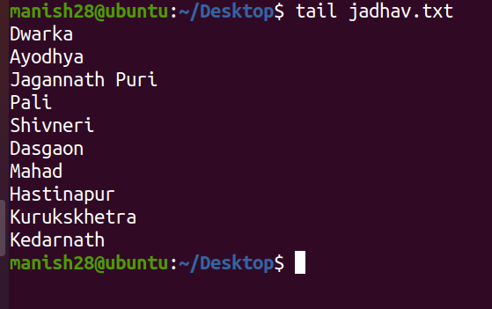

* **tail -v (data from the specified file is always preceded by its file name.):**

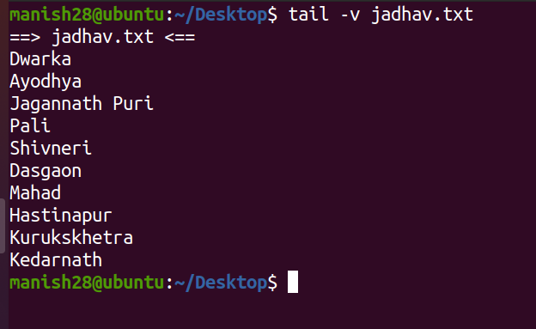

1. **cut command:**

* **cut -b (To extract the specific bytes without range):**

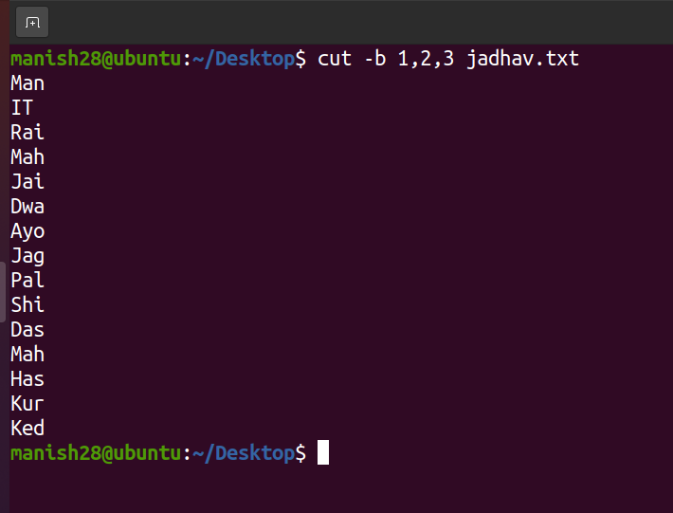

* **cut -b (To extract the specific bytes with range):**

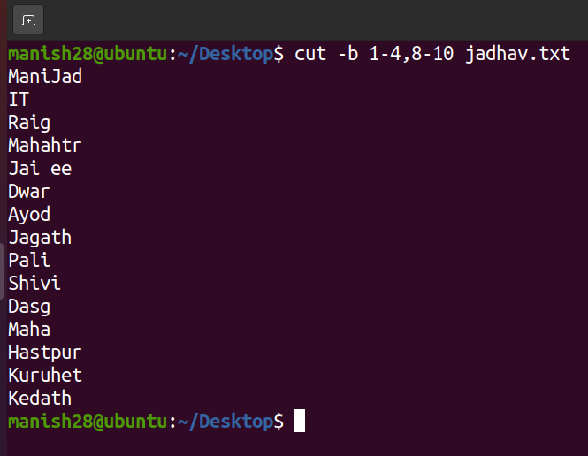

1. **paste command:**

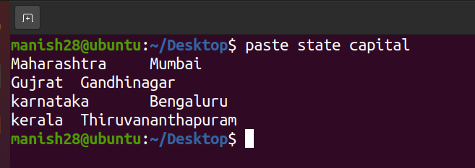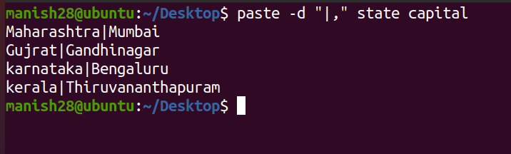

1. **sort command:**

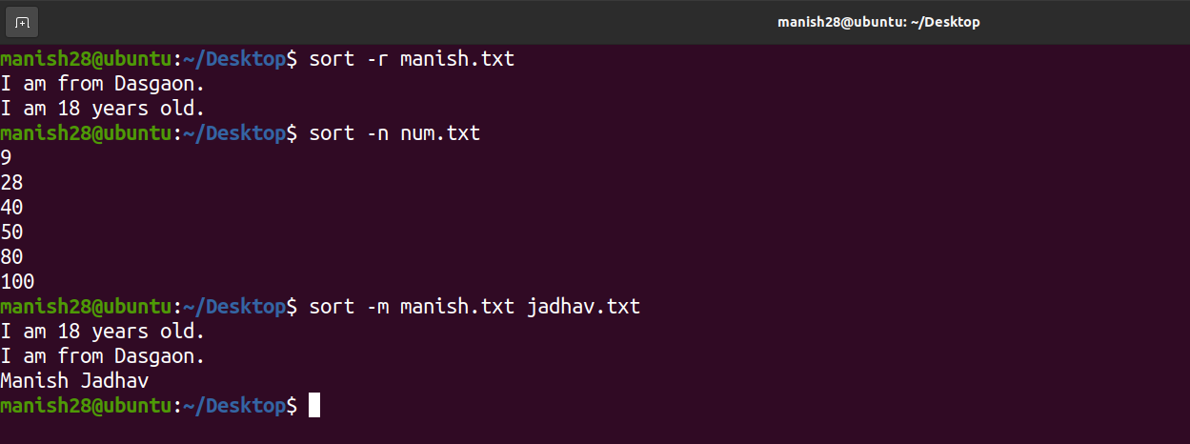

1. **uniq command:**

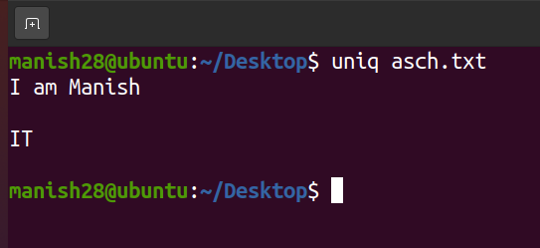

* **uniq -c (counts the number of duplicate line):**

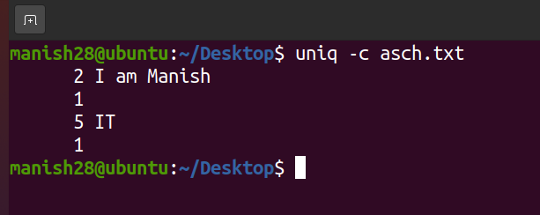

1. **tr command:**

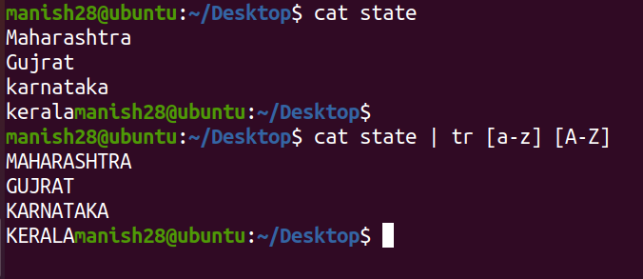

1. **grep command:**

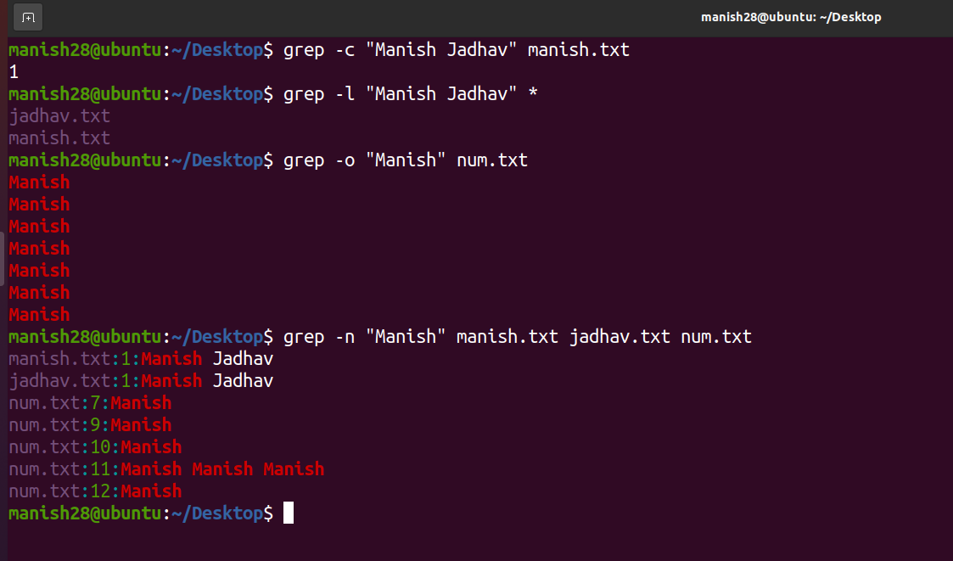

1. **sed command:**

* **Counts line number:**

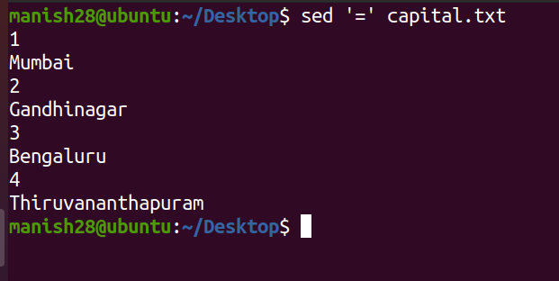

* **Removes the line with specified word:**

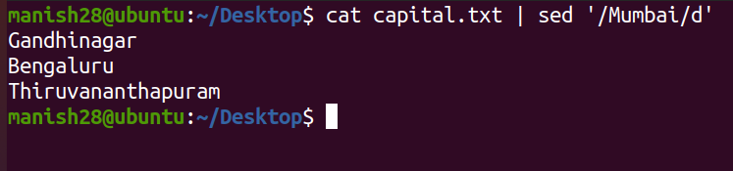

1. **awk command:**

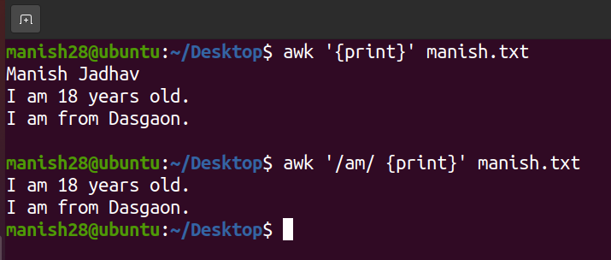

|  |  |  |  |
| --- | --- | --- | --- |
| **Practical Performance**  **(4)** | **Writeup & Oral**  **(4)** | **Attendance**  **(2)** | **Total**  **(10)** |
|  |  |  |  |